Gas Network Management Report

In order to maximize profit through a optimal flow through the network, we would need to send and receive in these amounts to each terminal:

|  | **Receiving** | | | | | | | | | | | |
| --- | --- | --- | --- | --- | --- | --- | --- | --- | --- | --- | --- | --- |
| **Sending** |  | **W** | **A** | **K** | **I** | **C** | **H** | **J** | **L** | **P** | **M** | **E** |
| **W** | **--** | **10** | **0** | **–** | **–** | **–** | **–** | **–** | **–** | **–** | **–** |
| **A** | **0** | **--** | **0** | **25** | **–** | **–** | **–** | **–** | **–** | **–** | **–** |
| **K** | **10** | **15** | **–** | **–** | **30** | **15** | **–** | **–** | **–** | **–** | **–** |
| **I** | **–** | **0** | **–** | **–** | **10** | **–** | **15** | **–** | **–** | **–** | **–** |
| **C** | **–** | **–** | **0** | **0** | **–** | **–** | **10** | **15** | **15** | **–** | **–** |
| **H** | **–** | **–** | **0** | **–** | **–** | **–** | **–** | **–** | **15** | **–** | **–** |
| **J** | **--** | **–** | **25** | **0** | **0** | **–** | **–** | **0** | **0** | **0** | **–** |
| **L** | **–** | **–** | **–** | **–** | **0** | **–** | **0** | **–** | **0** | **0** | **30** |
| **P** | **–** | **–** | **–** | **–** | **0** | **0** | **0** | **15** | **–** | **–** | **15** |
| **M** | **–** | **–** | **–** | **–** | **–** | **–** | **0** | **0** | **–** | **–** | **0** |
| **E** | **–** | **–** | **45** | **–** | **–** | **–** | **–** | **0** | **0** | **0** | **–** |

With this mix of sending and receiving values, the profit will be $228.45 (thousands) or $228,450.

Figure A)  
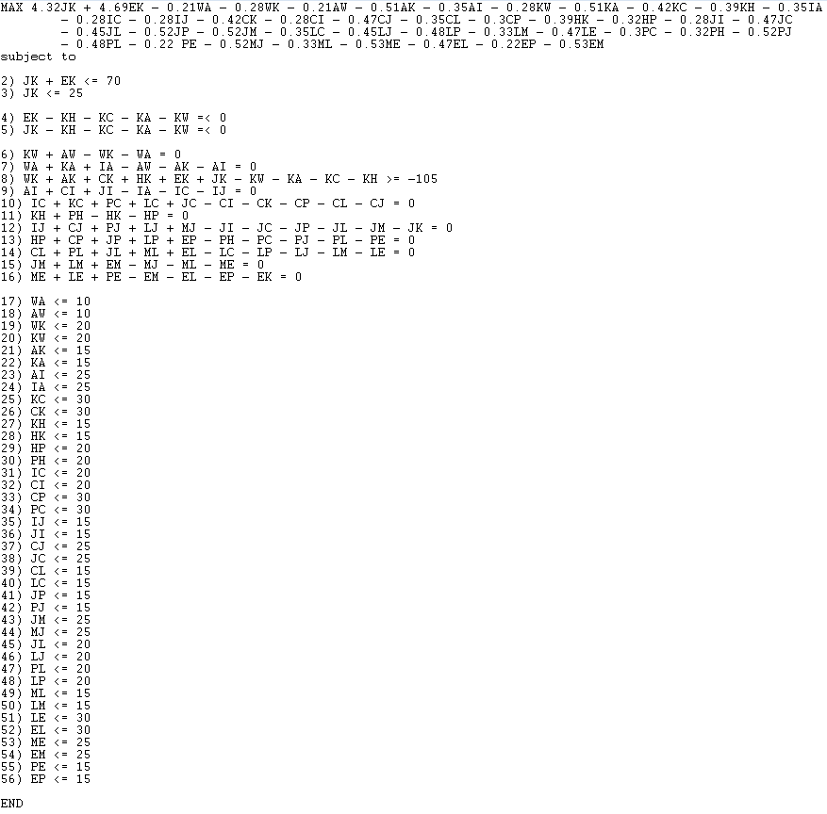

Figure B)

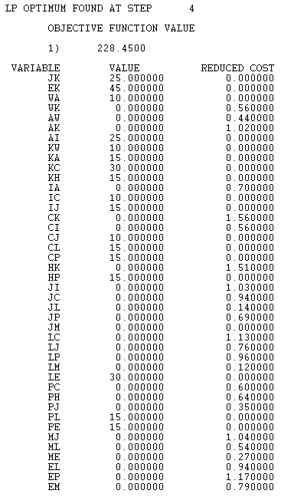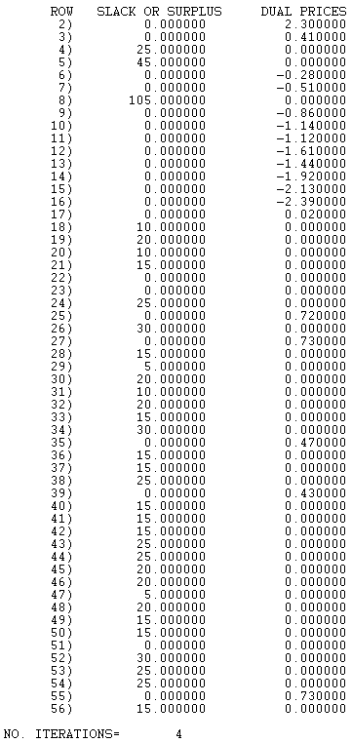

| Constraint | Proof of constraint being followed |
| --- | --- |
| 4.32JK + 4.69EK - 0.21WA - 0.28WK - 0.21AW - 0.51AK - 0.35AI - 0.28KW - 0.51KA - 0.42KC - 0.39KH -0.35IA - 0.28IC - 0.28IJ - 0.42CK - 0.28CI - 0.47CJ - 0.35CL - 0.3CP - 0.39HK - 0.32HP - 0.28JI - 0.47JC - 0.45JL - 0.52JP - 0.52JM - 0.35LC - 0.45LJ - 0.48LP - 0.33LM - 0.47LE - 0.3PC - 0.32PH - 0.52PJ - 0.48PL - 0.22 PE - 0.52MJ - 0.33ML - 0.53ME - 0.47EL - 0.22EP - 0.53EM = 228.45 | 4.32(25) + 4.69(45) - 0.21(10) - 0.28(0) - 0.21(0) - 0.51(0) - 0.35(25) - 0.28(10) - 0.51(15) - 0.42(30) - 0.39(15) -0.35(0) - 0.28(10) - 0.28(15) - 0.42(0) - 0.28(0) - 0.47(10) - 0.35(15) - 0.3(15) - 0.39(0) - 0.32(15) - 0.28(0) - 0.47(0) - 0.45(0) - 0.52(0) - 0.52(0) - 0.35(0) - 0.45(0) - 0.48(0) - 0.33(0) - 0.47(30) - 0.3(0) - 0.32(0) - 0.52(0) - 0.48(15) - 0.22 (15) - 0.52(0) - 0.33(0) - 0.53(0) - 0.47(0) - 0.22(0) - 0.53(0) = 228.45  228.45 = 228.45 |
| JK + EK <= 70 | 25 + 45 <= 70  70 <= 70 |
| JK <= 25 | 25 <= 25 |
| EK - KH - KC - KA - KW =< 0 | 45 - 15 - 30 - 15 - 10 =< 0  -25=< 0 |
| JK - KH - KC - KA - KW =< 0 | 25 - 15 - 30 - 15 - 10 =<0  -45=< 0 |
| KW + AW - WK - WA = 0 | 10 + 0 - 0 - 10 = 0  0 = 0 |
| WA + KA + IA - AW - AK - AI = 0 | 10 + 15 + 0 + 0 + 0 + 25 = 0  0 = 0 |
| WK + AK + CK + HK + EK + JK - KW - KA - KC - KH >= -105 | 0 + 0 + 0 + 0 + 45 + 25 -10 - 15 - 30 - 15 >= -105  0 >= -105 |
| AI + CI + JI - IA - IC - IJ = 0 | 25 + 0 + 0 - 0 - 10 - 15 = 0  0 = 0 |
| IC + KC + PC + LC + JC - CI - CK - CP - CL - CJ = 0 | 10 + 30 + 0 + 0 + 0 - 0 - 0 - 15 - 15 - 10 = 0  0 = 0 |
| KH + PH - HK - HP = 0 | 15 + 0 - 0 - 15 = 0  0 = 0 |
| IJ + CJ + PJ + LJ + MJ - JI - JC - JP - JL - JM - JK = 0 | 15 + 10 + 0 + 0 + 0 - 0 - 0 - 0 - 0 - 0 - 25 = 0  0 = 0 |
| HP + CP + JP + LP + EP - PH - PC - PJ - PL - PE = 0 | 15 + 15 + 0 + 0 + 0 - 0 - 0 - 15 -15 = 0  0 = 0 |
| CL + PL + JL + ML + EL - LC - LP - LJ - LM - LE = 0 | 15 + 15 + 0 + 0 + 0 - 0 - 0 - 0- 0 - 30 = 0  0 = 0 |
| JM + LM + EM - MJ - ML - ME = 0 | 0 + 0 + 0 - 0 - 0 - 0 = 0  0 = 0 |
| ME + LE + PE - EM - EL - EP - EK = 0 | 0 + 30 + 15 - 0 - 0 - 0 - 45 = 0  0 = 0 |
| WA <= 10 | 10 <= 10 |
| AW <= 10 | 0 <= 10 |
| WK <= 20 | 0 <= 20 |
| KW <= 20 | 10 <= 20 |
| AK <= 15 | 0 <= 15 |
| KA <= 15 | 15 <= 15 |
| AI <= 25 | 25 <= 25 |
| IA <= 25 | 0 <= 25 |
| KC <= 30 | 30 <= 30 |
| CK <= 30 | 0 <= 30 |
| KH <= 15 | 15 <= 15 |
| HK <= 15 | 0 <= 15 |
| HP <= 20 | 15 <= 20 |
| PH <= 20 | 0 <= 20 |
| IC <= 20 | 10 <= 20 |
| CI <= 20 | 0 <= 20 |
| CP <= 30 | 15 <= 30 |
| PC <= 30 | 0 <= 30 |
| IJ <= 15 | 15 <= 15 |
| JI <= 15 | 0 <= 15 |
| CJ <= 25 | 10 <= 25 |
| JC <= 25 | 0 <= 25 |
| CL <= 15 | 15 <= 15 |
| LC <= 15 | 0 <= 15 |
| JP <= 15 | 0 <= 15 |
| PJ <= 15 | 0 <= 15 |
| JM <= 25 | 0 <= 25 |
| MJ <= 25 | 0 <= 25 |
| JL <= 20 | 0 <= 20 |
| LJ <= 20 | 0 <= 20 |
| PL <= 20 | 15 <= 20 |
| LP <= 20 | 0 <= 20 |
| ML <= 15 | 0 <= 15 |
| LM <= 15 | 0 <= 15 |
| LE <= 30 | 30 <= 30 |
| EL <= 30 | 0 <= 30 |
| ME <= 25 | 0 <= 25 |
| EM <= 25 | 0 <= 25 |
| PE <= 15 | 15 <= 15 |
| EP <= 15 | 0 <= 15 |